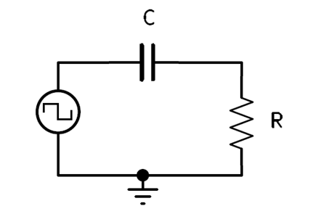Consider the following circuit:

**Differentiation**

* “Differentiation is a measure of rate of change.” (Bell p.56)
* There is more than enough time for the capacitor to fully charge and discharge.
  1. PW or PS is greater than $5τ$.
  2. “When RC is less than one-tenth of the pulse width, the capacitor is charged very rapidly. Only a brief pulse of current is necessary to charge and discharge the capacitor at the beginning and end of the pulse. The resultant waveform of the resistor voltage is a series of positive and negative spikes at the pulse leading and lagging edges, respectively.” (Bell p.56)
  3. The standard formulas for designing an Integrating RC circuit is:
 $RC= τ$

 $50\% DC, PW=PS$

 $PW=Time to charge, PS=Time to discharge$

 $RC$ + **= $(\frac{1}{10}PW)$** (Differentiation in terms of $τ$)
     + $Time =10×τ$ (Differentiation formula in terms of Time, lots of Time to charge or discharge)

See Image:

1. Is **not** a Differentiator, the capacitor is not fully charging or discharging.
2. Is **not** an Differentiator, $τ=$ PW. 63% charge and discharge
3. Is a **Differentiator,** the capacitor is fully charging and discharging within a relatively fast amount of time when comparted to the PW and PS and the resulting resistor voltage appears as positive and negative going spikes.

